DAY 13 | Implementation of XOR Gate using Verilog HDL
Introduction: An XOR (Exclusive OR) Gate is a digital logic gate that compares two input signals (A and B). The output becomes HIGH (1) when the inputs are different and LOW (0) when the inputs are the same. XOR gates are widely used in arithmetic circuits, parity generators, error detection circuits, and digital communication systems.
Boolean Expression: Y = A ^ B or Y = A'B + AB'
Truth Table:
A | B | Y
0 | 0 | 0
0 | 1 | 1
1 | 0 | 1
1 | 1 | 0
Working Principle: The XOR Gate compares two input signals. If both inputs are the same, the output is LOW. If the inputs are different, the output becomes HIGH. This makes the XOR Gate useful for comparison and error-checking applications.
Gate-Level Modeling: Gate-Level Modeling implements the XOR Gate using the built-in xor gate primitive in Verilog. This method closely represents the actual hardware implementation.
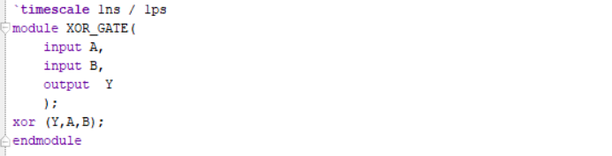
Dataflow Modeling: Dataflow Modeling uses the assign statement with the XOR (^) operator to implement the XOR Gate.
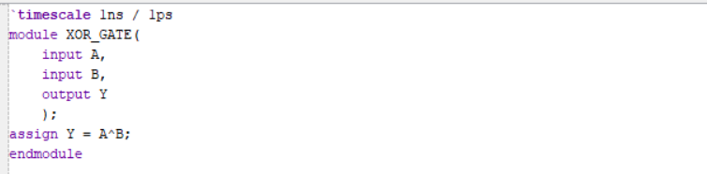

Behavioral Modeling: Behavioral Modeling uses an always @(*) block to describe the behavior of the XOR Gate. The output changes whenever either input changes.
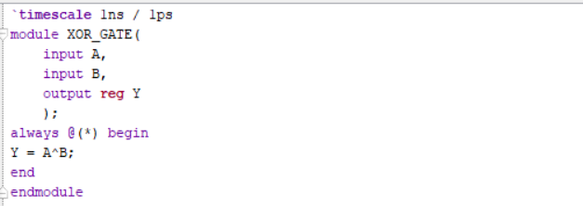
Testbench: The testbench verifies the XOR Gate by applying all possible input combinations and comparing the output with the expected truth table.
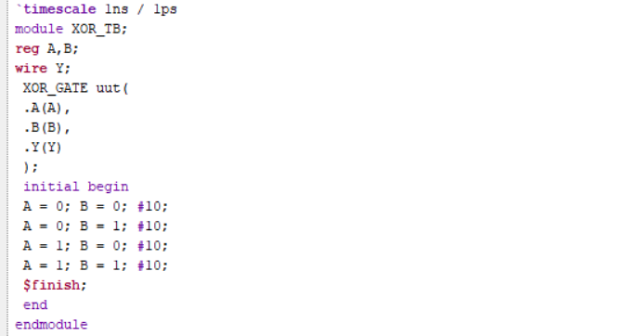

RTL Schematic: The RTL schematic generated by Xilinx Vivado represents the synthesized hardware implementation of the XOR Gate and confirms the correctness of the design.
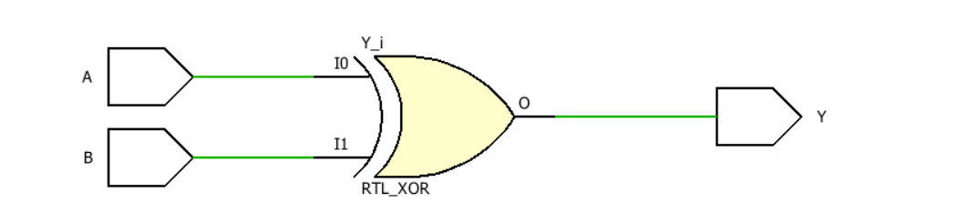

Simulation Waveform: The simulation waveform verifies that the output is HIGH only when the two inputs are different and LOW when both inputs are the same.
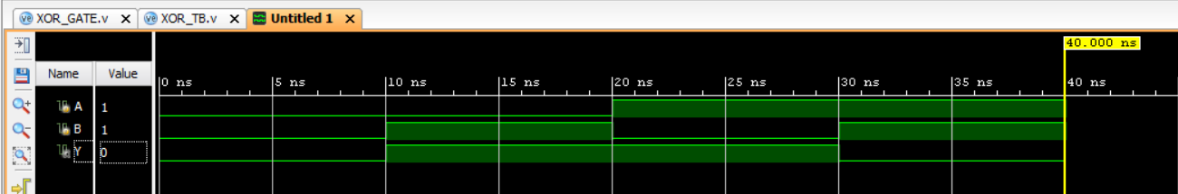

Observation:
• The output is HIGH when the inputs are different.
• The output is LOW when both inputs are the same.
• The RTL schematic correctly represents the XOR Gate.
• The simulation waveform matches the expected truth table.
• The Verilog implementation is successfully verified using Xilinx Vivado.

#PHANEENDRA.SINGUDASU

